Principles for planning AM to FM conversions in regional licence areas
september 2022
Canberra
Red Building
Benjamin Offices
Chan Street
Belconnen ACT
PO Box 78
Belconnen ACT 2616
T +61 2 6219 5555
F +61 2 6219 5353
Melbourne
Level 32
Melbourne Central Tower
360 Elizabeth Street
Melbourne VIC
PO Box 13112
Law Courts
Melbourne VIC 8010
T +61 3 9963 6800
F +61 3 9963 6899
Sydney
Level 5
The Bay Centre
65 Pirrama Road
Pyrmont NSW
PO Box Q500
Queen Victoria Building
NSW 1230
T +61 2 9334 7700 or 1800 226 667
F +61 2 9334 7799
Copyright notice
https://creativecommons.org/licenses/by/4.0/
With the exception of coats of arms, logos, emblems, images, other third-party material or devices protected by a trademark, this content is made available under the terms of the Creative Commons Attribution 4.0 International (CC BY 4.0) licence.
We request attribution as © Commonwealth of Australia (Australian Communications and Media Authority) 2022.
All other rights are reserved.
The Australian Communications and Media Authority has undertaken reasonable enquiries to identify material owned by third parties and secure permission for its reproduction. Permission may need to be obtained from third parties to re-use their material.
Written enquiries may be sent to:
Manager, Editorial Services
PO Box 13112
Law Courts
Melbourne VIC 8010
Email: info@acma.gov.au

Overview 1
Why we have adopted planning principles for conversions 1
How the planning principles will be applied 2
Consultation on the planning principles 2
Our expectations for the expanded conversion program 2
Background 4
How we plan broadcast spectrum 4
Future delivery of radio report 4
Expanding conversion program to non-solus regional licence areas 5
Planning principles 6
Principle 1: Service to be maintained for listeners 6
Principle 2: AM transmission to end after conversion 7
Principle 3: No replanning of existing services unless agreed between affected broadcasters 8
Principle 4: Spectrum to be put to efficient use 8
Principle 5: Conversions in solus markets currently underway to
be finalised 9
Principle 6: Industry to agree on proceeding with conversion
in competitive markets 9
Principle 7: Site selection and technical specifications to
maximise spectrum efficiency 10
Principle 8: Existing licence areas to stay the same 10
Process for conversions 11
1: Industry to request conversions 11
2: Industry consultants to develop technical planning solutions for conversions for the ACMA’s consideration 11
3: ACMA to consider spectrum needs in the wider area 11
4: ACMA to assess all planning requests for a licence area together 12
5: ACMA to consult on the conversion work program and other
planning priority activities 12
6: ACMA to consult on LAP variations when they are ready 13
Appendix: Interdependencies between regional
licence areas 14

Overview

Why we have adopted planning principles for conversions
FM conversion of AM services in regional areas has the potential to improve listener experience and support industry as it adapts to changing listener preferences. FM conversion can deliver improved audio quality, reduced signal interference and lower costs for broadcasters.
Since 2016, the Australian Communications and Media Authority (ACMA) has been working through a program to convert AM radio services to FM in solus (single licensee) regional commercial radio licence areas. As at August 2022, we had converted 23 of the 38 solus market licensees seeking conversions.
We began conversions in areas where spare FM spectrum was easiest to identify. As we move through the solus market program in areas where spectrum is congested, finding suitable spectrum is more difficult, with some listeners losing reception.
We have identified conversions as one of our broadcasting spectrum planning priorities, as they deliver outcomes for both listeners and industry. Improving coverage of existing services, planning for digital radio in regional areas where industry is committed to rolling out, and facilitating trials of new technologies are our other current broadcast planning focus areas.
While we continue to work with licensees in the remaining solus licence areas to find solutions and continue our other priority broadcast planning work, we are opening the program to other regional licence areas so we can deliver the benefits of FM to more regional listeners and broadcasters.
The goals of our conversion program are to ensure:
listeners continue to receive coverage
burdens are not imposed on industry by requiring other broadcasters to change frequencies
spectrum efficiency is maximised.
Expanding the conversion program to competitive markets requires a policy approach to deal with 3 issues in particular:
Equity issues between licensees – the current policy is not suitable as it addresses equity by limiting the conversion to non-competitive solus markets.
A more complex prioritisation process – prioritisation for competitive markets has more significant impact due to competing spectrum demand, as higher priority may mean being able to convert to FM or getting a better frequency.
Spectrum efficiency – which is more complex and important for the competitive markets due to spectrum scarcity.
We have adopted a set of planning principles to help inform the way we resolve these issues.
The planning principles provide clarity, transparency and consistency of our approach to the conversion in terms of eligibility, prioritisation, competitive equity, minimising detriment to existing broadcasters, maintaining services, improving quality for listeners, limiting coverage loss and maximising spectrum efficiency.
These planning principles replace ACMA’s approach to AM–FM conversions and infill transmitters for commercial radio broadcasting services – April 2017.

How the planning principles will be applied
The planning principles will apply to commercial radio conversions in the remaining regional solus licence areas and to regional competitive licence areas.
They will help to identify eligibility for inclusion in the conversion program for industry and to assist our prioritisation of conversion requests.
We expect industry participants to apply these planning principles when identifying which commercial services to convert, and when engaging consultant engineers to identify frequencies for conversion.
When we receive a conversion request in line with the principles, we will apply the statutory requirements in the BSA to come to a preliminary view. We will consult on specific proposals for AM to FM conversions.
As stated in The future delivery of radio report, we will not be converting AM services in metropolitan markets as part of this program.
Requests for conversions of AM community broadcasting and national services will continue to be assessed on a case-by-case basis in accordance with ACMA’s approach to broadcast planning and varying licence area plans, as a different set of objectives is applicable.

Consultation on the planning principles
In October 2021, we consulted about our proposed principles. We received 10 submissions.
Some submitters asked us to reconsider our current broadcast spectrum planning priorities (which are explained further in the next section) or delay the conversion program.
In response to submissions, we considered whether there was merit in reviewing our current broadcast planning priorities at this time.
Our view is that we can best support industry and audiences at this time by pursuing our current broadcast planning priorities. Our current priorities support AM to FM conversions, improving coverage where spectrum is available and digital rollout – both DAB+ rollout, further digital radio technology trials, and maintaining a ‘watching brief’ on DRM technology. This includes the results of any trials and developments in the deployment of DRM abroad.

Our expectations for the expanded conversion program
Given the benefit of conversions to industry and their listeners, we expect to receive a large number of conversion requests from licensees in competitive markets once the program is expanded.
Although we expect these planning principles to help guide and streamline the conversion process, we also expect to face many of the same challenges we encountered in the solus conversion program as we expand the program. One example is that identifying and resolving frequency planning issues often relies on the completion of critical commercial negotiations and decisions by the applicant before the ACMA can proceed with making broadcast spectrum planning decisions.
Because of this, we expect the regional competitive market conversion program as a whole will progress over a number of years and many individual conversion processes will themselves be complex and time-consuming.
Licensees can greatly assist the progress of the program by aligning their conversion requests with these planning principles.
In order to help us to progress conversions in an efficient and timely manner, we will require licensees to submit an ACMA Form B92 – Request to vary a licence area plan – radio (with guidance notes) – for the relevant LAP variation. We will require applicants to provide sufficient detail of their proposal, along with evidence-based supporting information, including detailed technical specifications of the current AM transmission and proposed FM transmission(s). We will also need the cooperation of licensees in responding promptly throughout the planning process to any necessary requests from the ACMA for further information. Without such details, we will be unable to assess proposals, and may need to reject particular requests.
Because there are other planning activities that can promote the objects of the BSA – such as improving coverage of existing services and facilitating trials of new technologies – we expect to continue to progress other broadcast planning activities in tandem with our conversion work.
We will assess requests for conversions along with other priority and non-priority LAP variation requests. We will prioritise, assess and respond to all LAP variation requests in line with the process set out in Part 3 of ACMA’s approach to broadcast planning and varying licence area plans.
Our decision about which request to progress and in what order will be guided by what would best promote the objects of the BSA.
We expect industry engagement to inform our decision-making process by providing feedback on the draft of the detailed work plan we will follow for the next 12 months when we consult on the draft five-year spectrum outlook (FYSO) in April to June
each year.

Background

How we plan broadcast spectrum
We plan broadcasting services in accordance with the specific broadcast spectrum planning provisions in Part 3 of the Broadcasting Services Act 1992 (the BSA).
The number and type of different broadcasting services in a licence area are set out in a licence area plan (LAP) made under subsection 26(1) of the BSA.
Whenever we plan a new radio service in a licence area, or change the technical specifications of an already planned radio service – such as replanning radio services from AM to FM spectrum – we need to vary the relevant radio LAP. Subsection 26(2) of the BSA gives us discretionary power to do this.
The process of AM to FM conversion is carried out as a request to vary a LAP’s technical specifications – including the authorised operating mode and frequency of a commercial radio broadcasting transmitter. The FM frequency is then included in a transmitter licence held by the licensee.
In considering the exercise of powers to vary a LAP to allow for conversion, or for any other reason, we are required to have regard to the criteria set out in section 23 of the BSA. Section 23 states we must perform our planning functions in a way that promotes the objects of the BSA, including the economic and efficient use of the radiofrequency spectrum.
Our general approach to planning for broadcasting services in the broadcasting services bands (BSBs), and how we make broadcast planning decisions for both television and radio, is set out in ACMA’s approach to broadcast spectrum planning and varying licence area plans document.

Future delivery of radio report
In 2019, we established the future delivery of radio project to ask Australian broadcasters and audio content providers about emerging technologies, the impact on their businesses and the choices these create for the radio industry. This includes how radio will be delivered to audiences in the future.
Our consultations confirmed that AM audiences are continuing to decline due to changes in audience preferences and the limitations in AM’s audio fidelity and interference susceptibility. Increasing levels of interference from noise sources due to urban growth, such as electrical machinery, electronic equipment, power lines and electric vehicles, are exacerbating the issue.
The audience drift in the current economic climate is resulting in weaker advertising revenue. Because of this, industry participants advised us that they see AM to FM conversions (or simulcasts where the AM coverage cannot be closely matched) where frequency availability permits, as their preferred solution in the short to medium-term to address the decline in AM audiences.
In response to the findings of our report on the future delivery of radio, we identified
4 broadcast planning priority activities to help support radio:
converting commercial, community and national radio broadcasting services from AM to FM where available
improving the coverage of radio broadcasting services where spectrum is readily available
making digital radio channel plans for regional DAB+ where there is a planned rollout
supporting trials of new broadcasting technology.

Expanding conversion program to non-solus regional licence areas
We consider opening the conversion program to solus markets with over 30% population overlap, and to non-solus licence areas (that is, competitive areas) in regional areas, promotes the objects of the BSA and the economic and efficient use of spectrum for the following reasons:
Promotes diverse range of services
The greater fidelity of FM allows a wider range of potential formats than AM.
We will continue to ensure that the existing reach of AM services is closely matched or that AM is available in simulcast.
Facilitates development of an industry that is efficient, competitive and responsive to audience needs
Will assist the industry to manage the slow decline in AM audiences and allow broadcasters to provide formats that listeners seek.
Compared to AM, FM provides improved outcomes for listeners in terms of better fidelity and better interference immunity.
Switching AM off provides savings for broadcasters, for example, in energy costs, site rentals, opportunity cost of land, and tower maintenance.
Promotes economic and efficient use of spectrum
We consider providing FM frequencies to closely match AM coverage (within a licence area for licensed broadcasters) is generally an economic and efficient use of spectrum. Whether a specific proposed LAP variation would result in an economic and efficient use of spectrum needs to be determined at the individual service-planning stage.
Where an FM conversion and any associated FM infill repeaters are not able to closely match AM coverage, we will generally expect the service to be simulcast in both AM and FM for a period of years. We do not consider this coverage duplication to be wasteful of spectrum, noting that the AM band currently has little alternative value, and the communicated desire of the industry to move to alternative delivery platforms.
Given the complexities and time required to complete the remaining regional solus market conversions, we are opening the conversion program to regional competitive markets while we continue to work on engineering solutions for the remaining solus markets.
This will allow the benefits of FM to be made available to listeners in more areas,
more quickly.

Planning principles
The following principles are proposed to guide the exercise of our power to vary licence area plans to convert AM radio broadcasting transmissions to FM in regional licence areas under subsection 26(2) of the BSA.
These planning principles are not intended to be binding on the ACMA, but represent a statement of disposition to guide our prioritisation of planning work.
From time-to-time during the planning process, circumstances may arise where it is necessary and appropriate for the ACMA to depart from the planning principles. In these instances, we will provide information about any proposed significant departure from the planning principles during a consultation process.
Requests for AM to FM conversions from licensees of community radio and national broadcasting services will continue to be considered on a case-by-case basis, in line with ACMA’s approach to broadcast planning and varying licence area plans. However, we will use these principles when considering requests to convert these services, particularly those aimed at continued coverage for listeners, minimising impact on other broadcasters and achieving spectrum efficiency.
A decision to vary a licence area plan under subsection 26(2) of the BSA is made by legislative instrument. Before making a legislative instrument, we must be satisfied that appropriate consultation, as is reasonably practicable, has been undertaken.
The order of the principles does not indicate their relative importance. How we balance the principles will be assessed on a case-by-case basis.

Principle 1: Service to be maintained for listeners
We will plan conversions to minimise loss of service to listeners.
The benefits of AM to FM conversion to audiences cannot be realised by those who lose the service as a result of conversion.
For this reason, we expect that, as far as is practical, FM conversion should minimise loss of service and not result in any significant coverage differences for radio listeners.
To assess coverage loss, we will assess the proportion of the population likely to receive the new FM transmission in comparison to the population coverage of the current AM transmitter within the licensee’s licence area.
The approximation of AM coverage may require FM in-fill repeaters as well as a main FM transmitter. When we look at whether FM conversion of a licence is in the public interest, we will consider whether any necessary in-fill repeaters will be deployed
and maintained.
We will also consider whether the FM coverage of a converting service will be similar to the coverage of the existing FM services within the same licence area.
Consistent with the approach applied to the non-competitive markets that have already converted, in considering whether the ‘vast majority’ of listeners can still receive a service, we will have regard to the section 23 planning criteria, including:
Demographics – the proportion of the population within the licence area who receive the AM service that is no longer predicted to receive a service, and the distribution of that population. We will also use the assumption in the ACMA approach to broadcast planning that, when planning the technical characteristics of services, communities with a population of 200 people or more are entitled to expect a service from a broadcaster that is licensed to provide one.
The number of existing broadcasting services within the licence area – the extent of alternative services available to listeners may be a consideration, as will any available information on listening habits in the area.
The technical constraints relating to the delivery or reception of broadcasting services.
Any other relevant matters.
We recognise that in some cases, it may not be practical or feasible to fully resolve coverage loss resulting from an AM to FM conversion within a licence area, which may affect the existing AM service listeners. For this reason:
We may consider proposals that reduce coverage loss in spectrum-congested areas and ensure that listeners have access to a variety of broadcasting services. Note, this is a change from the current policy.
If there is not any other practical or feasible way to reduce coverage loss, we will expect the service to be simulcast (dual coverage) in both AM and FM. We would expect the licensee to commit to maintaining AM transmission by making a deed poll to this effect in favour of the ACMA. The minimum time that AM is to be maintained will be assessed on a case-by-case basis, but is expected to be a number of years. Note, this is a change from the current policy.
We will not approve conversion proposals where a failure to achieve similar coverage is simply a function of the commercial preference of a licensee.

Principle 2: AM transmission to end after conversion
This is a conversion program. We expect AM transmissions to fully convert to FM as part of this program unless it is not feasible to do so.
In order to transition listeners to the FM transmission, we will generally require a
28-day simulcast period as a minimum requirement, with the AM transmitter to be turned off at the end of the simulcast period. We may permit simulcasting for a longer transition period if the circumstances warrant it.
We do not propose to plan for FM transmitters to provide FM services only to more populous areas within a licence area, such as major towns, while other parts of the licence area receive AM, in circumstances where FM spectrum is readily available across the licence area.
If AM coverage within the licence area can be closely matched in FM, we would generally not agree to long-term simulcasts, unless there was a demonstrated benefit to listeners or another good reason.
An example of where we may permit long-term simulcasts is in licence areas where higher-density population centres are surrounded by large areas of low density and highly-dispersed populations.
In such circumstances, we may consider applications for dual coverage on a case-by-case basis. In considering such an application, we will take into account competing spectrum needs in the licence area and in adjacent licence areas, if applicable. As noted in Principle 1, we will expect the licensee to make a deed poll in favour of the ACMA to maintain the AM transmission for a number of years.
In circumstances where closely matching the coverage is not practical or effective, we are prepared to consider a licensee’s request to keep AM operating to provide fringe coverage. Note, this is a change from the current policy.

Principle 3: No replanning of existing services unless agreed between affected broadcasters
We consider that the benefits of conversion to the licensee and to their audience will not usually be sufficient to warrant imposing costs on other licensees, due to required changes to operating frequencies, transmission sites or other changes to technical parameters of the affected service.
For this reason, we do not propose to re-plan existing services to make way for conversions unless there is an agreement between the converting broadcaster and the affected broadcaster over the mitigation of costs.
It will be a matter for the converting broadcaster to broker the agreement.
We may facilitate options – such as swapping frequencies between a broadcaster seeking conversion and other broadcasters – if the converting licensee provides us with a written agreement developed with the other licensees.
However, before facilitating such an arrangement, we would need to form our own view about whether such an arrangement would support the objects and broadcasting planning criteria under the BSA.
We will also only plan conversions that do not result in interference to existing broadcasters, or overspill into other licence areas, beyond what is strictly necessary to provide the service.

Principle 4: Spectrum to be put to efficient use
We consider it is generally more efficient to make use of spectrum, as soon as practicable, if it promotes the objects of the BSA.
In some regions, limited frequency availability may mean a conversion of all licensees across a number of markets is not possible. In these circumstances, where an AM broadcaster does not progress planning work for conversion within a reasonable timeframe, available frequencies may be used to facilitate conversion of other AM services where a licensee’s willingness to proceed is clear.
We are also prepared to consider repurposing unused FM spectrum for AM to FM conversion. This may include spectrum planned for in LAPs but not currently being used, as well as unused allotments for national broadcasters. We will consult the national broadcasters in these circumstances before making any decisions to
this effect.
Whether unused spectrum is to be repurposed will be decided on a case-by-case basis, following public consultation.
When assessing conversion requests for an area, we will consider the purpose of any ministerial reservation that gave rise to the allotment of spectrum for national broadcasters, and the national broadcasters’ own plans for conversions and service extensions. We will also consider the availability of spectrum for potential conversions of national services at a future date.
We will assess and weigh possible competing uses of broadcasting spectrum on a case-by-case basis to achieve the optimal planning outcome according to the section 23 planning criteria.

Principle 5: Conversions in solus markets currently underway to be finalised
We will continue to consider and progress current proposals for conversions in non-competitive markets, while we open the program for conversions in competitive areas so that more listeners can benefit.
We expect to finalise the requests in non-competitive markets that are currently underway and where appropriate spectrum has already been identified. If there is a competing spectrum demand in a region for the conversion of services in a non-competitive market that is already being progressed, and a competitive market where a new request has been submitted, we will generally expect to give spectrum access priority and plan for the conversion in the non-competitive market. This will be subject to conducting a case-by-case assessment against the objects of the BSA and the planning criteria in section 23 of the BSA.
As a part of this assessment, we may consider whether it better promotes the objects of the BSA to use spectrum to plan for conversions in non-competitive markets or deliver benefits to more listeners by planning for conversions in larger population centres in competitive markets.
However, a decision to cease a conversion process that is already underway would require compelling justification.

Principle 6: Industry to agree on proceeding with conversion in competitive markets
We expect industry to be involved throughout the conversion process and to collectively agree to conversion arrangements, including any competing spectrum access issues between commercial radio licensees in competitive markets.
The FM frequency band in many regional licence areas is already congested, which means it may not be possible to find a suitable frequency to fulfil all conversion requests.
At the start of a conversion process, we expect commercial radio licensees in competitive licence areas to come to a settled position about the spectrum access priority order for conversion of commercial radio services. This advice will inform any resolution of competing spectrum demand in areas where there is not enough spectrum to convert all AM services. We have identified licence areas that are likely to have interdependent spectrum demands in the Appendix.
Before we start progressing each conversion request in a competitive market, we expect evidence of an agreement on conversion, reached between commercial radio licensees in a licence area and, where relevant, across interdependent licence areas. The agreement should include resolution of any identified spectrum access issues.
All commercial radio conversion requests will be assessed with all other requests for spectrum access, according to ACMA’s approach to broadcast planning and varying licence area plans. Generally, we will assess all conversion requests – whether from commercial radio licensees, national broadcasters or community radio broadcasting licensees – in the order we receive them. If, during the initial assessment of a commercial radio conversion request, or at any other point during the process it becomes apparent that there are competing spectrum demands between commercial radio licensees within a licence area or a region, we will go back to industry with the expectation that the relevant licensees resolve the issues.
We will pause the work on the requests in question while we await the resolution and continue working on other unaffected requests.
Although we expect industry to resolve spectrum access issues between competing commercial radio licences, we will assess all conversion requests – commercial, national and community – according to our statutory requirements. Therefore, agreement is a precondition to our progressing conversion requests, but it is not the only factor that we will consider when deciding whether to approve conversion.
We will also assess all other spectrum access requests according to these statutory requirements, and as informed by our consultation process. We will resolve competing demands for spectrum between commercial radio licensees and national broadcasters and community licensees by applying the decision-making framework in Part 3 of the BSA.

Principle 7: Site selection and technical specifications to maximise spectrum efficiency
We will provide guidance and assess the proposed technical planning solutions for conversion requests on the basis of what will maximise spectrum efficiency.
While a broadcaster may have a commercial preference to have a particular site location or transmitter specifications, our statutory planning responsibilities require us to ensure radiofrequency spectrum is used in an economic and efficient manner.
This requires consideration of factors other than the preferences of a licensee and may mean that a licensee’s preference is not accepted.

Principle 8: Existing licence areas to stay the same
We consider that licence areas are fixed markets that will not be aggregated or reduced for conversions.
While we do not plan for, or protect, fortuitous reception, we may consider whether listeners in one licence area can receive comparable FM services from another licence area, when assessing conversion requests.
For example, we may take account of fortuitous coverage, where a conversion would result in a listening audience losing the fortuitous reception of the AM service (being the only service it can receive), and it would be unable to receive the service fortuitously once converted to FM.

Process for conversions

1: Industry to request conversions
In line with Principle 6, we expect competing licensees in neighbouring or interdependent licence areas to collectively reach a settled position about which commercial radio services they would prefer us to convert.
When making a conversion request (using the B92 form), we expect industry to provide evidence of the agreement between all affected commercial licensees, as outlined in Principle 6, before we progress the request.

2: Industry consultants to develop technical planning solutions for conversions for the ACMA’s consideration
We will consider the reports from industry consultants for most requests for commercial conversions. Note, the ACMA does not expect this for other non-commercial LAP variation requests.
This work is to be conducted in accordance with our engineering guidance set out on our broadcast planning resources web page. This provides guidance on how frequencies are to be selected for new services without compromising existing services through interference.
Once the consultant’s work is complete, we will assess the engineering work and work with the consultant to resolve any engineering concerns.

3: ACMA to consider spectrum needs in the wider area
As is our usual practice, we will consider interdependent licence areas as a group when conversion planning.
Consideration of existing services in adjacent or interdependent licence areas and those of national or community broadcasters is relevant because they may constrain the availability of frequencies in the area being planned.
It may not be possible to progress conversions in the area until spectrum needed for conversion in neighbouring or interdependent areas is identified.
In line with Principle 6, if we identify competing spectrum demands, the relevant licensees will need to come to an agreement about access to spectrum before we continue our work on the conversion(s) in question.

4: ACMA to assess all planning requests for a licence area together
We will assess all outstanding requests – whether or not they are for conversion – that relate to a particular LAP when we consider conversion requests for a licence area.
There may be cases where we have one or more LAP variation requests on hand that would compete for an available frequency.
Conversions will not necessarily be given priority to access spectrum over other spectrum uses.
In all cases, we will consider which use of the spectrum best promotes the objects of the BSA.

5: ACMA to consult on the conversion work program and other planning priority activities
We will include conversions in our annual work program, in accordance with industry advice, as part of the FYSO process. We will include conversion requests for the remaining solus licence areas and future competitive licence areas, as we work through the engineering and policy issues.
We generally progress conversion requests using the first-in-time method for each stage of the process. This is effectively how non-competitive markets conversions have been processed to date. This means that in each stage of the process, requests are processed chronologically as requested information relevant to that stage is received. Markets that are ready would move to the next stage, whereas others, where more complex issues are encountered, may stay longer in a particular stage.
To minimise delays, all conversions in regional markets will be considered to be on an equal footing when setting the work plan priorities.
We will prioritise regional conversion requests, along with our other broadcast spectrum planning priorities. The annual work program will also contain our initiatives, such as technical studies and replanning proposals.
Currently, the FYSO only reflects those LAP variation tasks where all the engineering and policy issues have been resolved and the related LAP is ready to be consulted on and made. It is proposed that in the future, the scope of the projects in the FYSO would be widened to include the prioritisation and the status of work in the earlier stages in the planning process, including flagging the licence areas for which we are awaiting feedback from, or resolution by, industry.
Although prioritised planning activities, including conversions, will generally proceed ahead of non-prioritised activities, this may not always be the case. In some cases, we may consider a lower priority request may better promote the objects of the BSA than a request in a higher-priority class because it is a more economic and efficient use of spectrum in the specific circumstances.
It may sometimes be efficient for us to progress other LAP variation requests and broadcast spectrum planning tasks, while engineering solutions for conversions in particular areas are worked through with industry consultation engineers. If, at any stage of the process, engineering or policy issues are identified that affect multiple licensees, we will go back to industry with the expectation that the relevant licensees resolve the identified issues. We will pause the work on the requests in question while we await the resolution and continue working on other, unaffected, requests. We will use the FYSO process to update industry on any changes to our annual work plan, such as adding additional planning work and advising of unanticipated delays.

6: ACMA to consult on LAP variations when they are ready
We will consult on LAP variations in the order that they are prepared, rather than in the order in which requests are received by the ACMA.
There may be delays in resolving engineering issues, or assessing policy issues, which means that some requests will be easier and quicker to progress than others. Rather than delay the conversion program, we will prepare consultation packages when the agreed planning solution is complete, subject to our other work priorities.
To maximise efficiency and move the program forward, we may not always be able to follow the anticipated timeframes outlined in the FYSO. We will update industry of any changes through the FYSO process.

Appendix: Interdependencies between regional licence areas
This appendix provides a preliminary analysis of the interdependencies between regional licence areas with AM services.
Solus licence areas with commercial AM service where conversion has been requested
State | Licence area | Interdependencies
New South Wales | Griffith | Southern NSW/Western Victoria
 | Gunnedah | Inland NSW
 | Inverell | Inland NSW
 | Lismore | n/a
 | Lithgow | n/a
 | Moree | n/a
 | Mudgee | n/a
 | Parkes | n/a
 | Tamworth | n/a
 | Wagga Wagga | Southern NSW/Western Victoria
 | Young | n/a
South Australia | Mt Gambier | n/a
Victoria | Colac | Southern NSW/Western Victoria
 | Hamilton | Southern NSW/Western Victoria
 | Horsham | Southern NSW/Western Victoria
 | Swan Hill | Southern NSW/Western Victoria
 | Wangaratta | n/a
Western Australia | Albany | n/a
 | Bridgetown | South West WA
 | Esperance | Ungrouped
 | Kalgoorlie | Ungrouped
 | Katanning | SW WA
 | Merredin | SW WA
 | Narrogin | SW WA
 | Northam | SW WA
Notes:
Interdependency groupings are listed in Table 4. Where ACMA engineering staff have accepted, or are considering, an AM to FM conversion, interdependency no longer needs to be considered so these licence areas are shown as not applicable (n/a).
Lithgow has a greater than 30% overlap with the Katoomba licence area but is treated as a non-30% solus market given that the Lithgow AM coverage is poor in the overlap area. Consequently, the Lithgow licensee has implemented FM repeaters in the overlap area.
Mudgee RA1 and Mudgee RA3 have been treated as a single solus licence area rather than 2 separate solus licence areas with a near 100% overlap.
Solus licence areas with commercial AM service with greater than 30% population overlap
State | Licence area | Interdependencies | Overlap
New South Wales | Deniliquin | Southern NSW/Western Victoria | 61% overlap with Shepparton, 30% overlap with Bendigo
 | Murwillumbah | Ungrouped | 66% overlap with Gold Coast
 | Muswellbrook | Hunter | 33% overlap with Newcastle
Victoria | Maryborough | Central Victoria | 98% overlap with Bendigo
 | Sale | Gippsland | 42% overlap with Warragul

Competitive regional licence areas with commercial AM service(s)
State | Licence area | Interdependencies | No. of commercial AM transmissions
Australian Capital Territory | Canberra | Ungrouped | 2
New South Wales | Albury | Central Victoria | 1
 | Coffs Harbour | North Coast NSW | 1
 | Dubbo | Inland NSW | 1 + 1 repeater
 | Kempsey | North Coast NSW | 1
 | Newcastle | Hunter | 1
 | Orange | Inland NSW | 1
Queensland | Atherton | Far North Queensland | 1 + 1 repeater
 | Bundaberg | Central Queensland | 1
 | Cairns | Far North Queensland | 1 + 1 repeater
 | Emerald | Central Queensland | 1 + 2 repeaters
 | Gympie | Central Queensland | 1
 | Kingaroy | Central Queensland | 1
 | Mackay | Central Queensland | 1
 | Maryborough | Central Queensland | 1
 | Mount Isa | Ungrouped | 1 + 1 repeater
 | Rockhampton | Central Queensland | 2 + 2 repeaters
 | Roma | Central Queensland | 1
 | Toowoomba/  Warwick | Central Queensland | 3
Victoria | Ballarat | Central Victoria | 1
 | Mildura | Southern NSW/Wester Victoria | 1
 | Shepparton | Central Victoria | 1
 | Warragul | Gippsland | 1
Western Australia | Bunbury | South West WA | 2 + 4 repeaters

List of interdependency groupings
Grouping | Licence area | Non-competitive/Competitive
Far North Queensland | Atherton | Competitive
 | Cairns | Competitive
 | Innisfail | Non-competitive
Western Queensland | Charleville | Non-competitive
 | Charters Towers | Non-competitive
 | Longreach | Non-competitive
Central Queensland | Bundaberg | Competitive
 | Emerald | Competitive
 | Gympie | Competitive
 | Kingaroy | Competitive
 | Mackay | Competitive
 | Maryborough | Competitive
 | Rockhampton | Competitive
 | Roma | Competitive
 | Toowoomba/Warwick | Competitive
North Coast NSW | Coffs Harbour | Competitive
 | Kempsey | Competitive
Hunter | Muswellbrook | Competitive
 | Newcastle | Competitive
Inland NSW | Dubbo | Competitive
 | Gunnedah | Non-competitive
 | Inverell | Non-competitive
 | Orange | Competitive
Gippsland | Sale | Competitive
 | Warragul | Competitive
Central Victoria | Albury | Competitive
 | Ballarat | Competitive
 | Maryborough | Competitive
 | Shepparton | Competitive
Southern NSW/Western Victoria | Colac | Non-competitive
 | Deniliquin | Competitive
 | Griffith | Non-competitive
 | Hamilton | Non-competitive
 | Horsham | Non-competitive
 | Swan Hill | Non-competitive
 | Mildura | Competitive
 | Wagga Wagga | Non-competitive
South West  WA | Bridgetown | Non-competitive
 | Bunbury | Competitive
 | Katanning | Non-competitive
 | Merredin | Non-competitive
 | Narrogin | Non-competitive
 | Northam | Non-competitive
Ungrouped | Alice Springs | Non-competitive
 | Broken Hill | Non-competitive
 | Canberra | Competitive
 | Carnarvon | Non-competitive
 | Esperance | Non-competitive
 | Kalgoorlie | Non-competitive
 | Mount Isa | Competitive
 | Murwillumbah | Competitive
Notes:
This assessment is preliminary.
For the purposes of this table, we have only considered competing demand for spectrum from AM conversion in same or adjacent licence areas, and have not considered possible FM demand for other purposes, such as demand for conversion of national and community services.
Solus licence areas with greater than 30% overlap are considered competitive markets.
The table incudes solus licence areas with AM commercial services where a request was not made or withdrawn.
Nominal groupings map
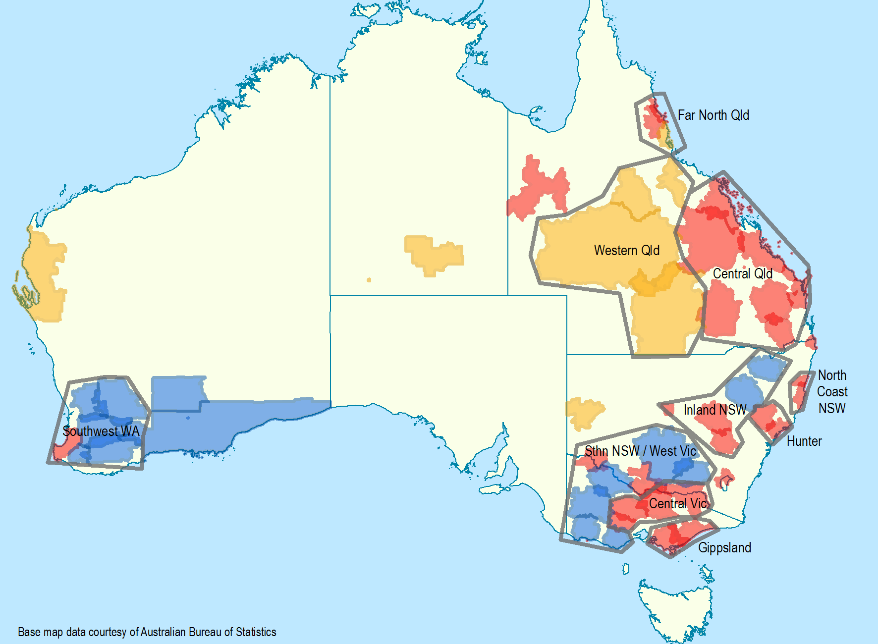
Key:
Blue licence areas – licence areas where we have received a conversion request, but no frequency selection has been confirmed.
Orange licence areas – solus licence areas where we have not received an expression of interest.
Red licence areas – competitive markets with AM services, including solus licence areas with greater than 30% overlap.
Grey outlined polygons – these are nominal interdependency groupings. Licence areas shown outside these polygons are ungrouped. Each of these is shown in greater detail in the following maps.

Far North Queensland interdependency grouping – Atherton, Cairns and Innisfail licence areas
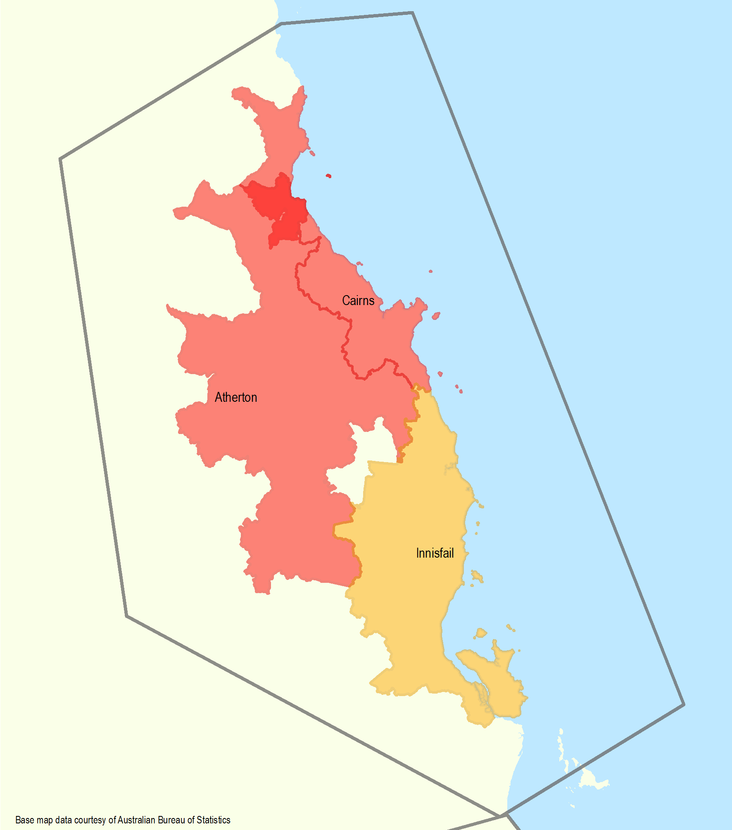

Western Queensland interdependency grouping – Charleville, Charters Towers and Longreach licence areas
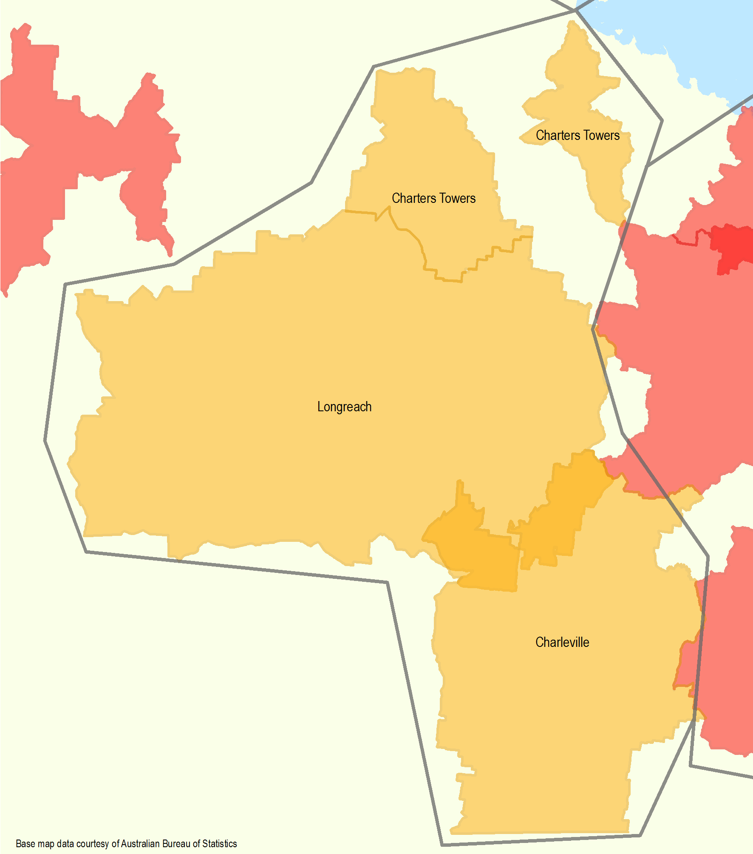

Central Queensland interdependency grouping – Bundaberg, Emerald, Gympie, Kingaroy, Mackay, Maryborough, Rockhampton, Roma and Toowoomba/Warwick licence areas
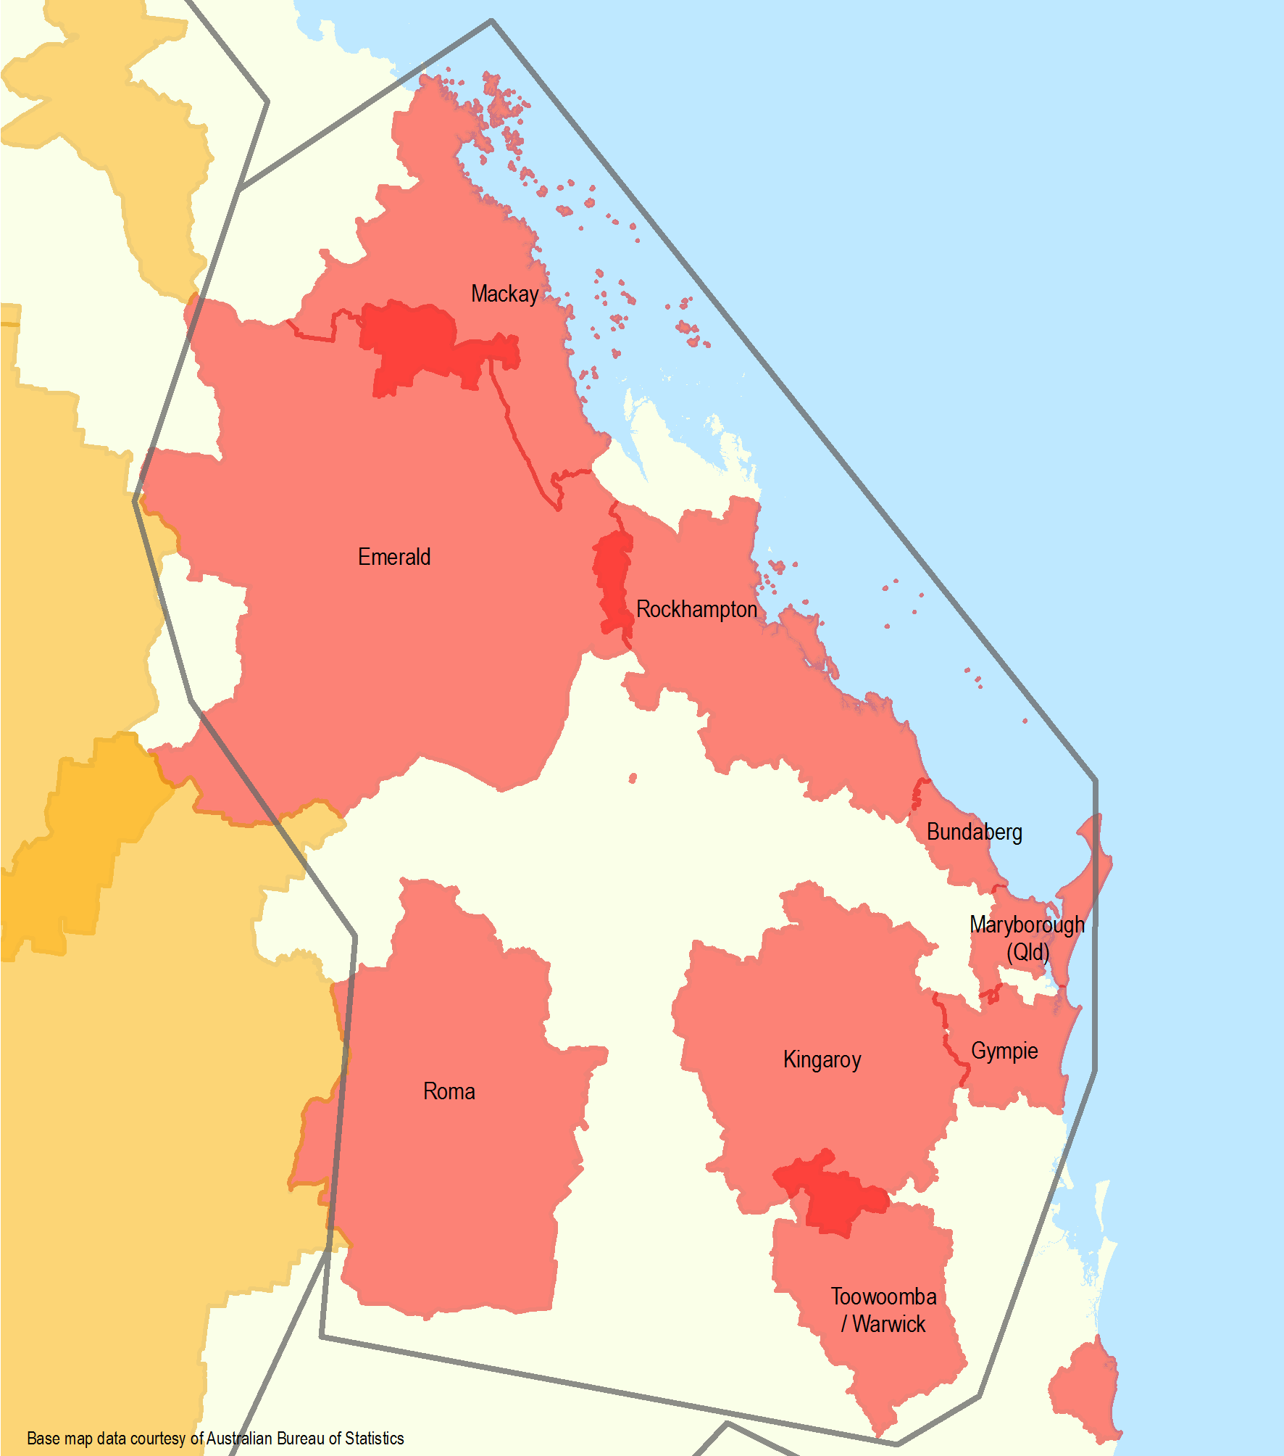

Inland NSW, North Coast NSW and Hunter interdependency groupings
Inland NSW: Dubbo, Gunnedah, Inverell and Orange licence areas
North Coast NSW: Coffs Harbour and Kempsey licence areas
Hunter: Muswellbrook and Newcastle licence areas
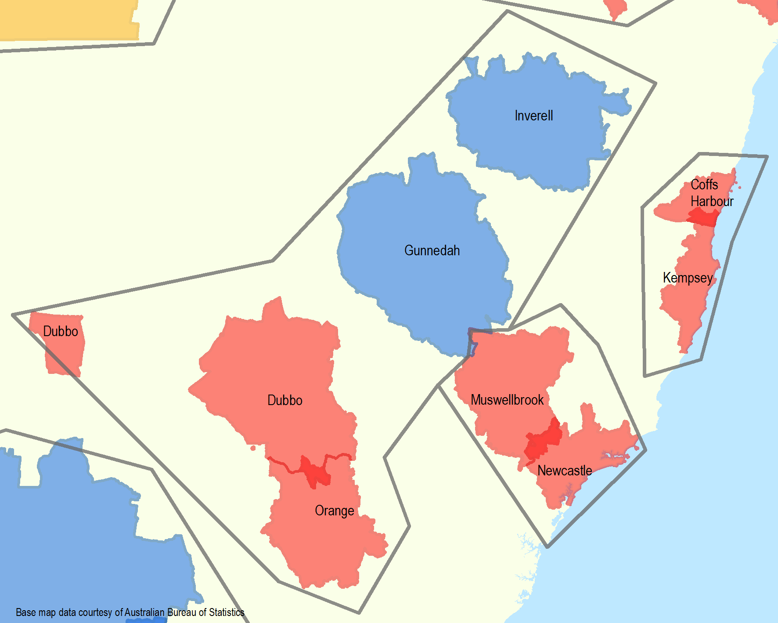

Southern NSW/Western Victoria, Central Victoria and Gippsland interdependency groupings
Southern NSW/West Victoria: Colac, Deniliquin, Griffith, Horsham, Hamilton, Mildura, Swan Hill and Wagga Wagga licence areas
Central Victoria: Albury, Ballarat, Maryborough and Shepparton licence areas
Gippsland: Sale and Warragul licence areas
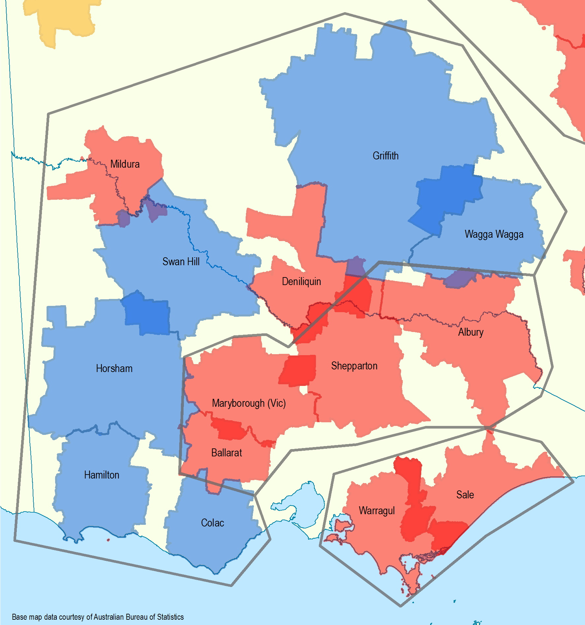

South West WA interdependency grouping – Bridgetown, Bunbury, Katanning, Merredin, Narrogin and Northam licence areas
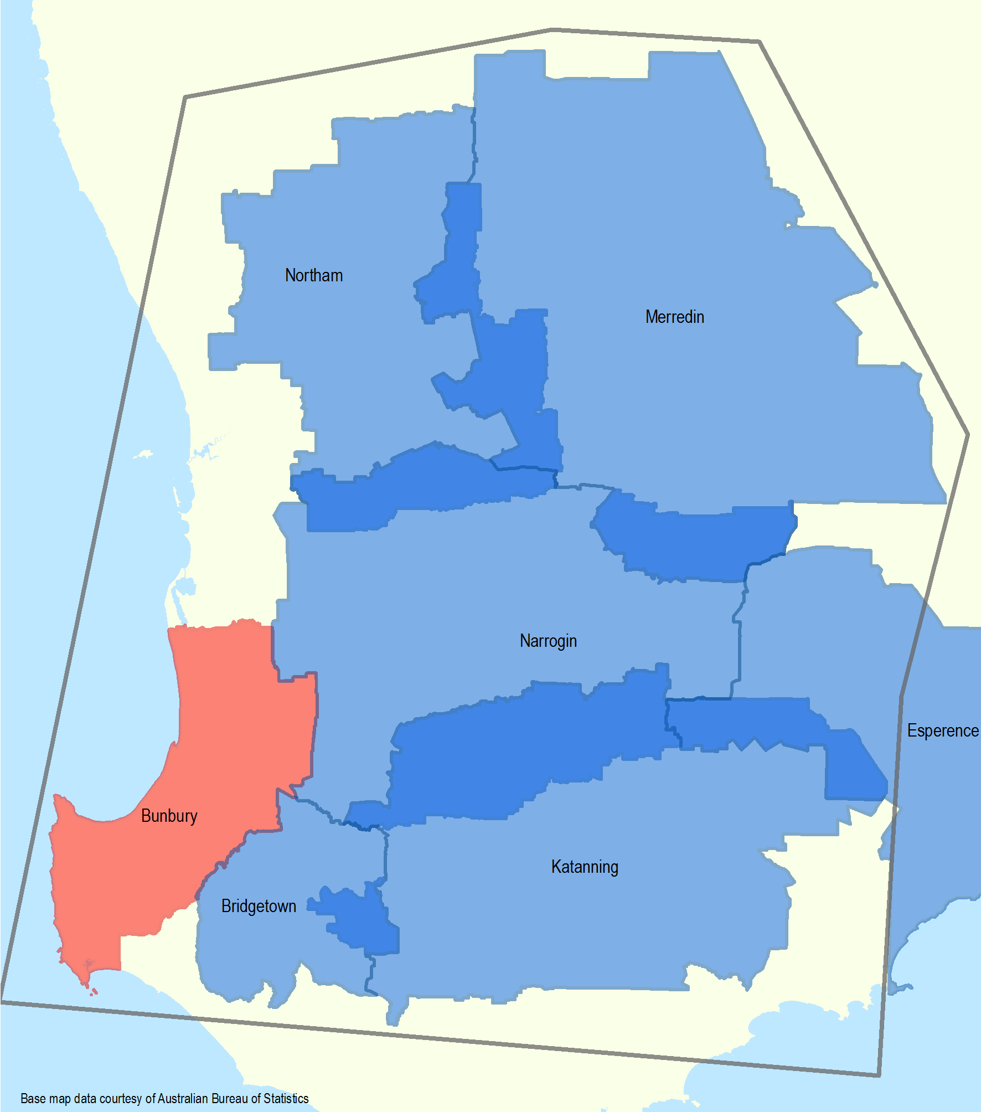

In September 2022, the ACMA released an outcome statement following consultation on options to replan the FM band in Perth to allow for conversions of AM services to FM.
See section 17 of the Legislation Act 2003.
A repeater is a broadcast transmitter that repeats (or transponds) the signal of a radio or television station to an area not covered by the originating station. It expands the broadcast range of a radio station beyond the primary signal's original coverage or improves service in the original coverage area.
For a typical conversion process, the stages may include the following: ACMA produces guidance notes; consultant engineer prepares initial report; ACMA evaluates initial report; consultant engineer prepares final report; ACMA evaluates final engineering report; ACMA accepts final engineering report; ACMA prepares consultation package; ACMA decision to consult; public consultation; ACMA prepares final decision post-public consultation, and ACMA final decision.

